Steps to execute/run the project

1. Software’s required:
   1. Visual Studio 2022
   2. SQL Server 2017 or above
2. Download the project zip file from github : <https://github.com/AartiShinde15/IAEA_Coding_Assessment.git>
3. Open the project in Visual Studio 2022 by selecting

File => Open => Project/Solution

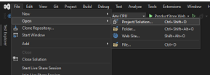

Or double click on solution file at folder location to open the project in Visual Studio 2022

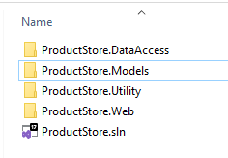

1. Open the appSettings.json file in project and update the Default connection string details

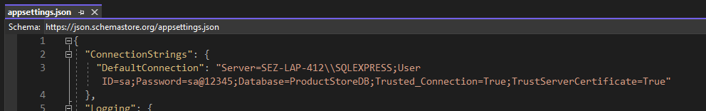

You need to add the Server name of your local SQL Server in above DefaultConnection and save the file

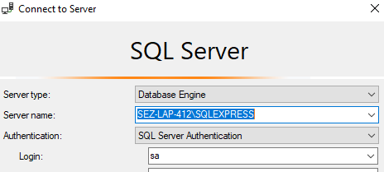

1. Select Tools => NuGet Package Manager => Package Manager Console

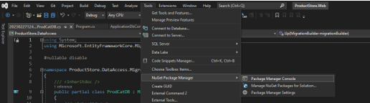

In Console select the Default Project as ‘ProductStore.DataAccess’

And execute below two commands, first execute

add-migration ProductStoreDb

then execute second command

update-database

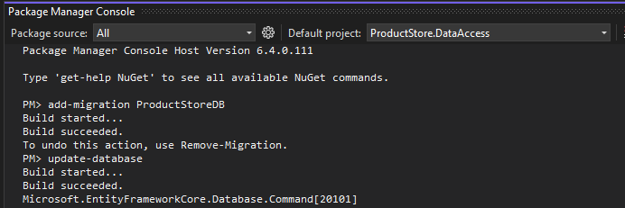

1. While executing the above commands in case you get some errors then you need to install below packages from NuGet Package Manager for EntityFramework to the solution (if they are not already installed)

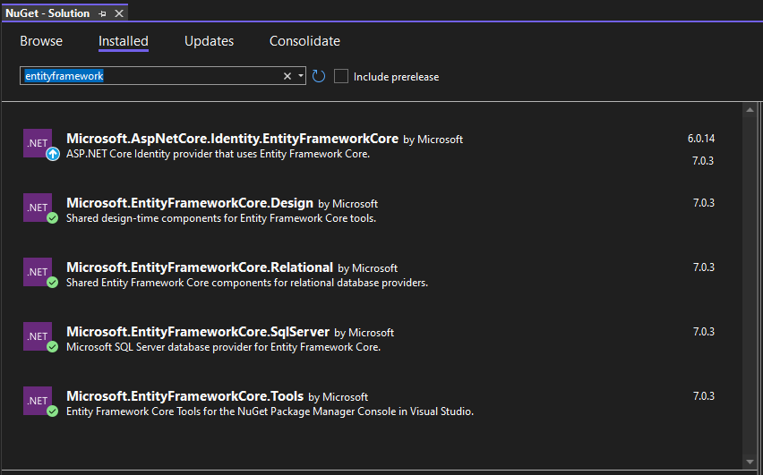

1. After successful execution of above commands open the SQL Server Management Studio and you can see the Database has got created with the name that is mentioned in ConnectionString

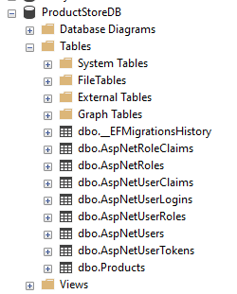

Also under ProductStore.DataAccess you can see the migration files are created

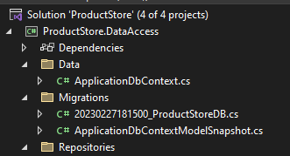

1. Application screenshots
   1. Home Page

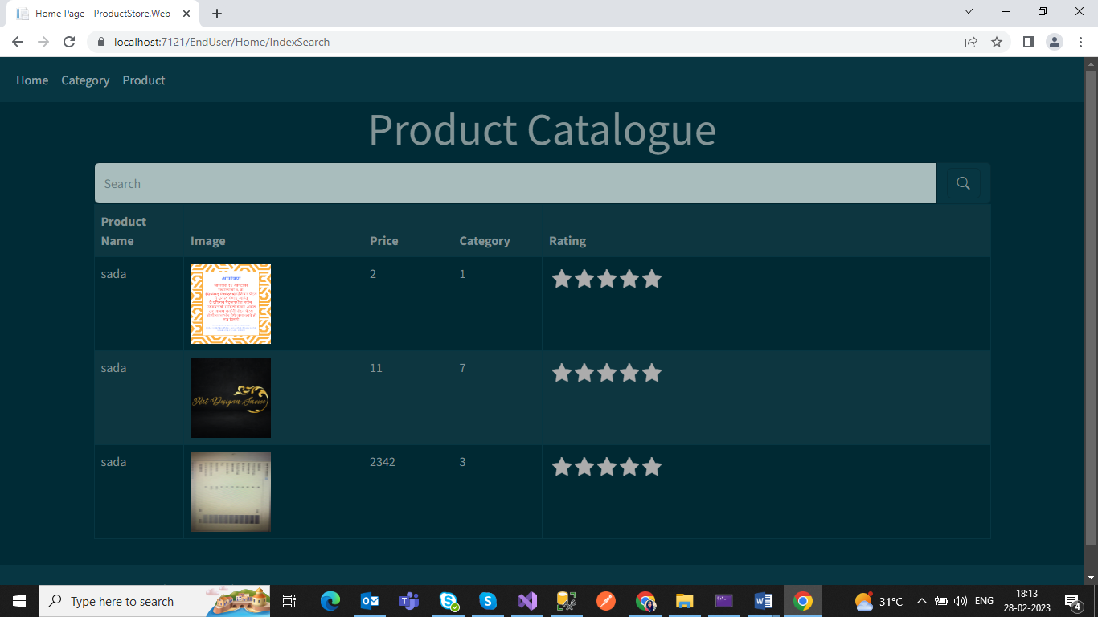

* 1. Home Page with search

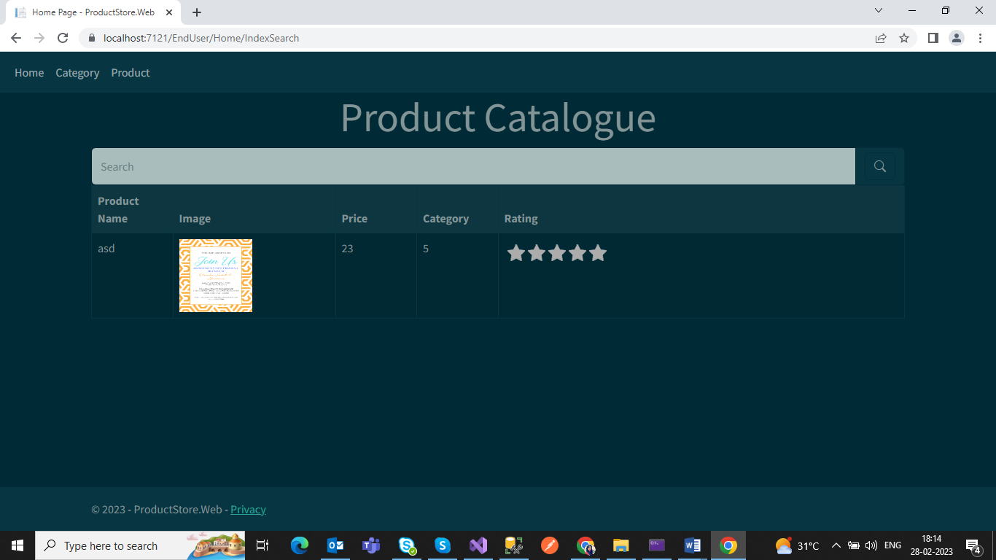

* 1. Category List Page

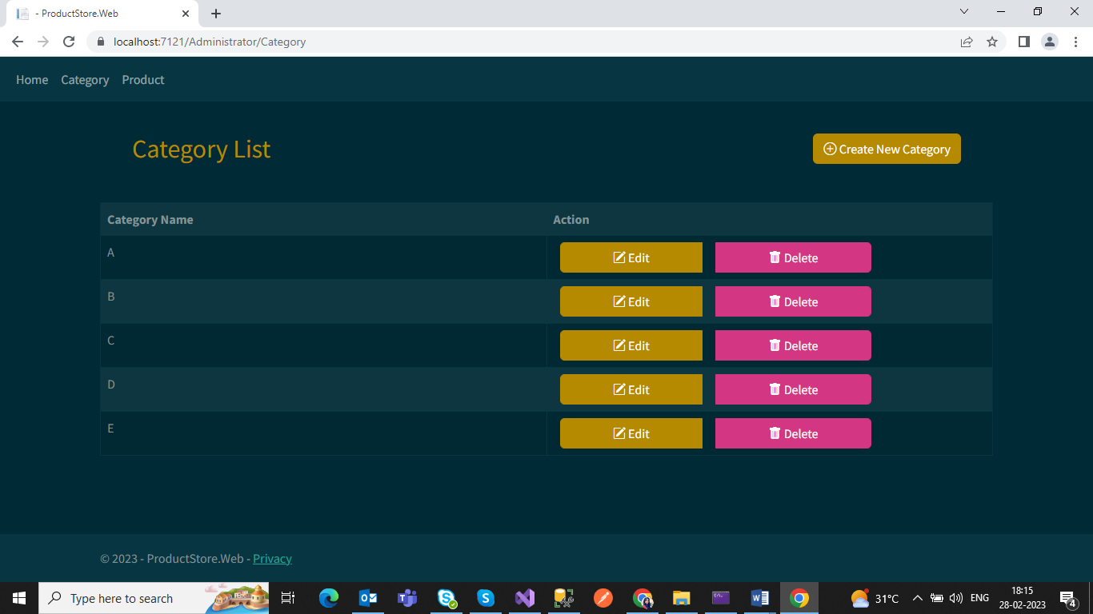

* 1. Create New Category

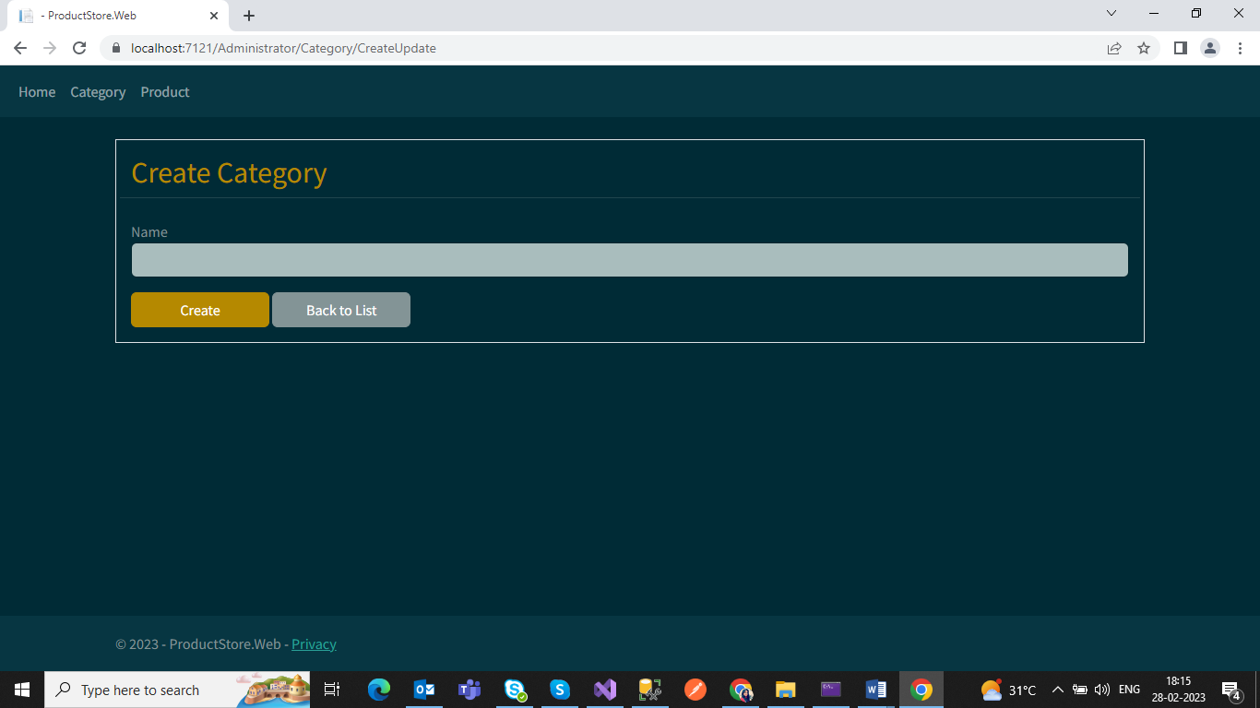

* 1. Edit Category

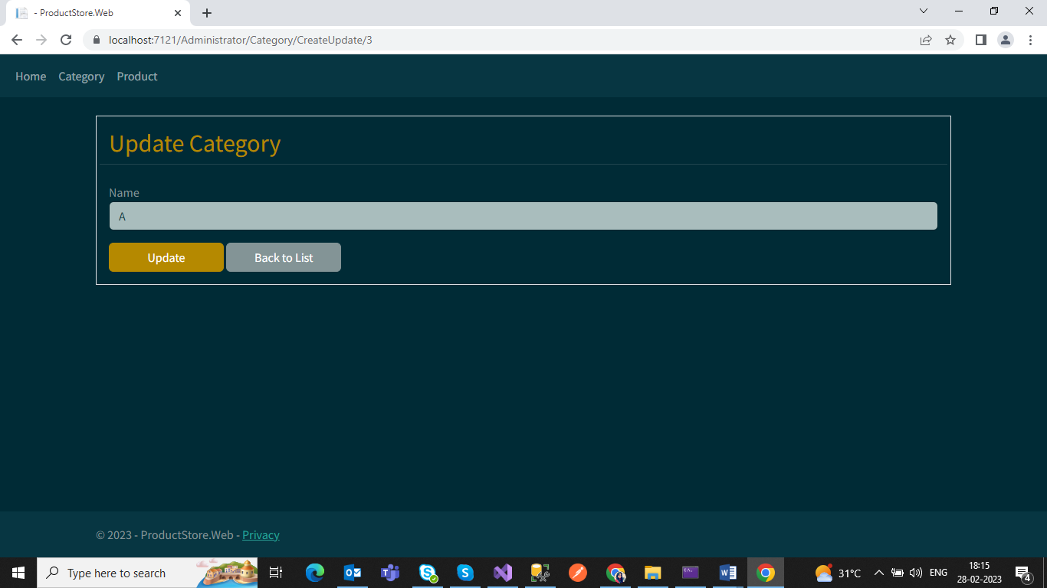

* 1. Delete Category

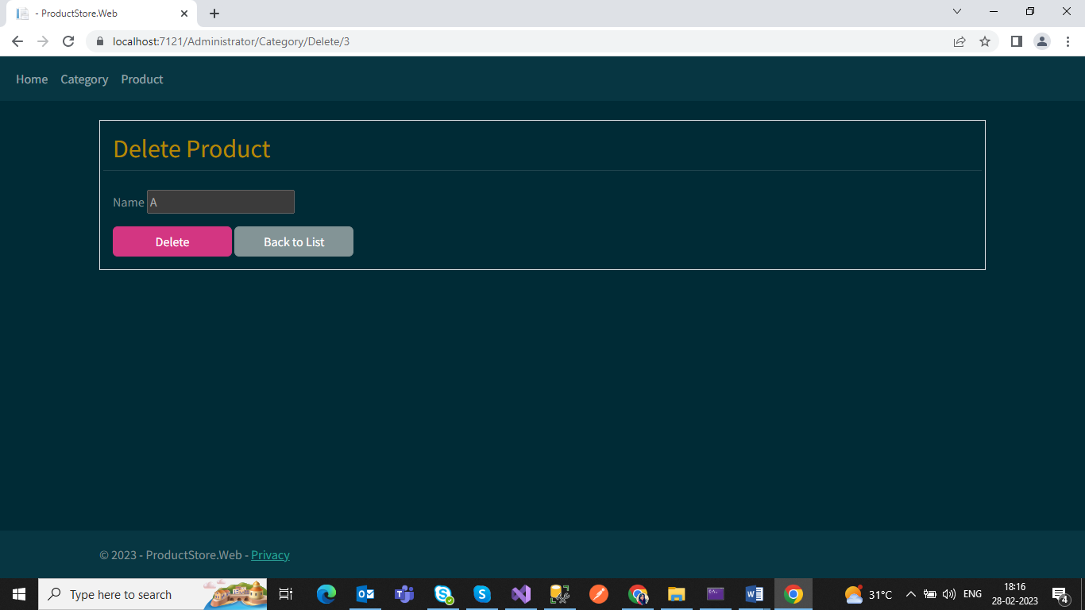

* 1. Product List Page

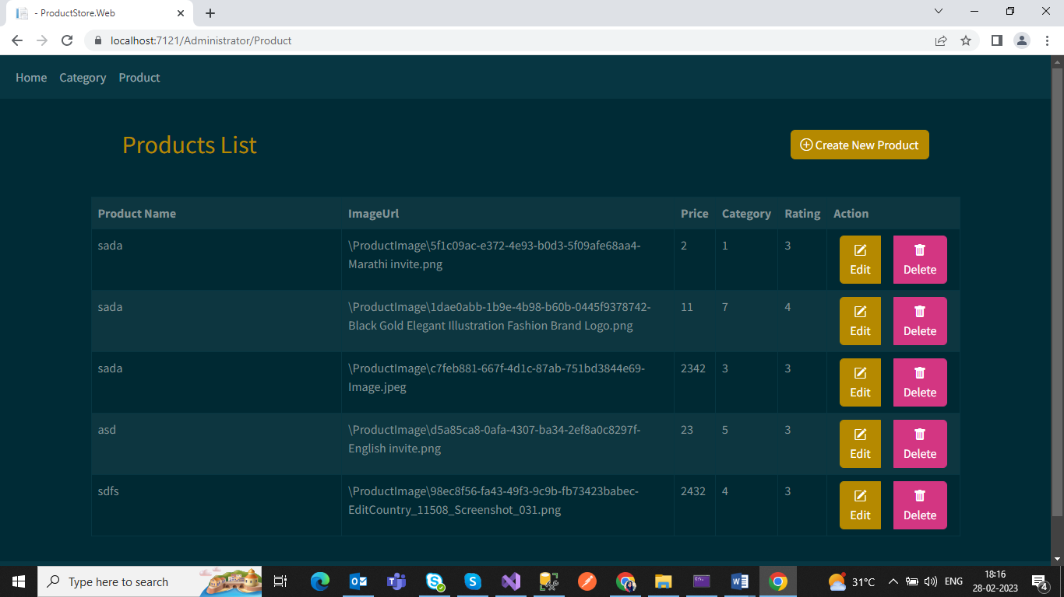

* 1. Create New Product

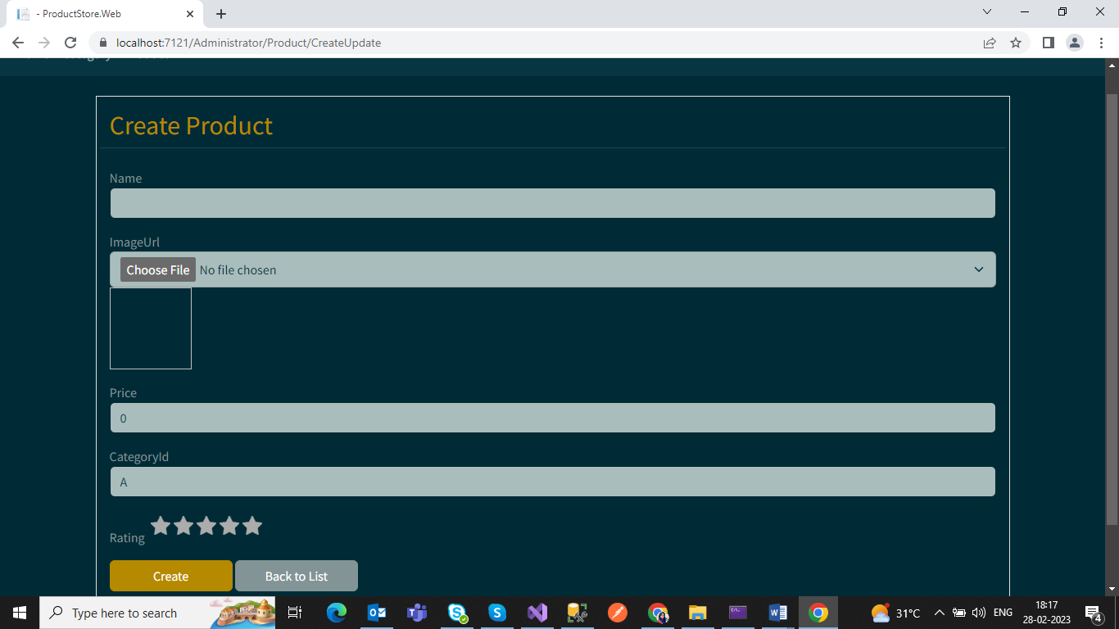

* 1. Update Product

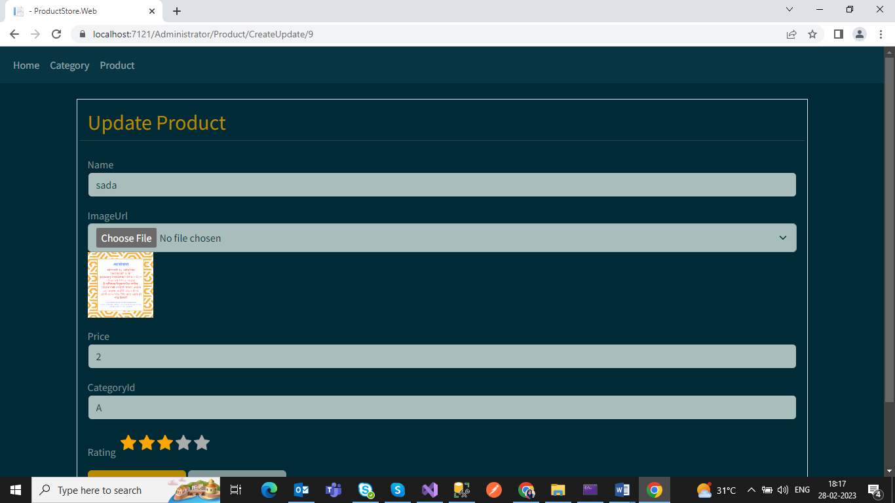

* 1. Delete Product

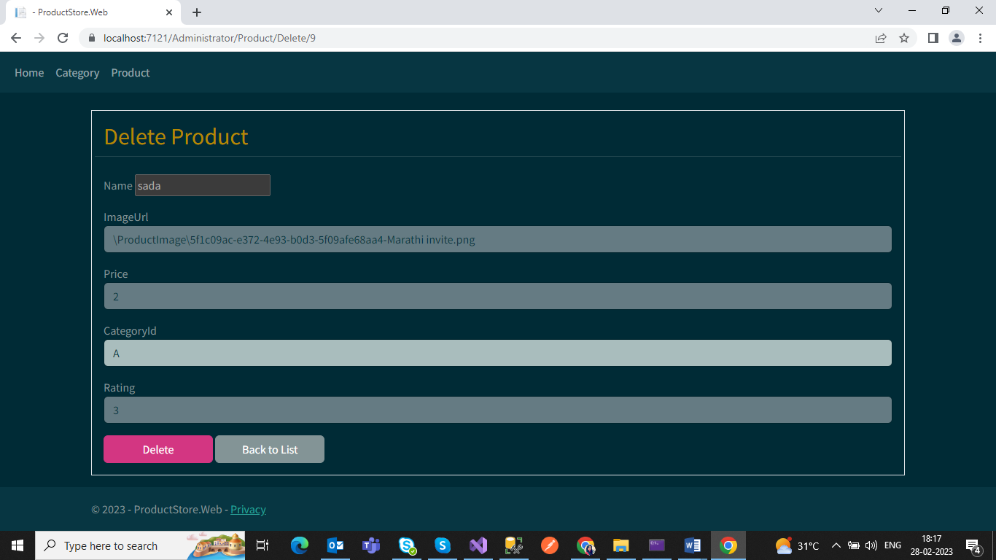

* 1. Sort List